**REPORT**

**ON**

**Enhancing Customer Convenience: Freshco Hypermarket's Home Delivery Service and Transaction Data Analysis**

**BY**

**SANDEEP KATAKIYA**

**Overview: Freshco Hypermarket's Customer-Centric Approach:**

Freshco Hypermarket, located in HSR, Bangalore, has introduced a home delivery service and maintains a detailed transaction data sheet to better serve its customers.

**Home Delivery Service:**

Freshco now offers home delivery, allowing customers to shop conveniently from the comfort of their homes. This service is powered by advanced technology and efficient logistics, ensuring timely delivery of a wide range of products.

**Transaction Data Sheet:**

Freshco keeps track of every order with a comprehensive transaction data sheet. This sheet contains detailed information about orders, customers, and delivery logistics. By maintaining these records, Freshco gains insights into customer preferences and shopping patterns.

* Order Level Analysis:  
    
  Understanding individual orders helps you uncover trends in order frequency, average order value, popular goods, and delivery completion rates.
* Completion Rate Analysis:  
    
  Assessing the completion rate of home delivery orders to gain a better understanding of delivery efficiency and customer satisfaction.
* Customer-Level Analysis:  
    
  Analyzing individual consumers' order history, frequency of purchases, average order value, and satisfaction ratings to gather insights about their behavior, preferences, and loyalty.
* Delivery Analysis:

involves examining variables including time, accuracy, driver efficiency, and customer feedback to discover opportunities for improvement in the delivery process.

**Order level analysis**

**order distribution at slot and delivery area level.**

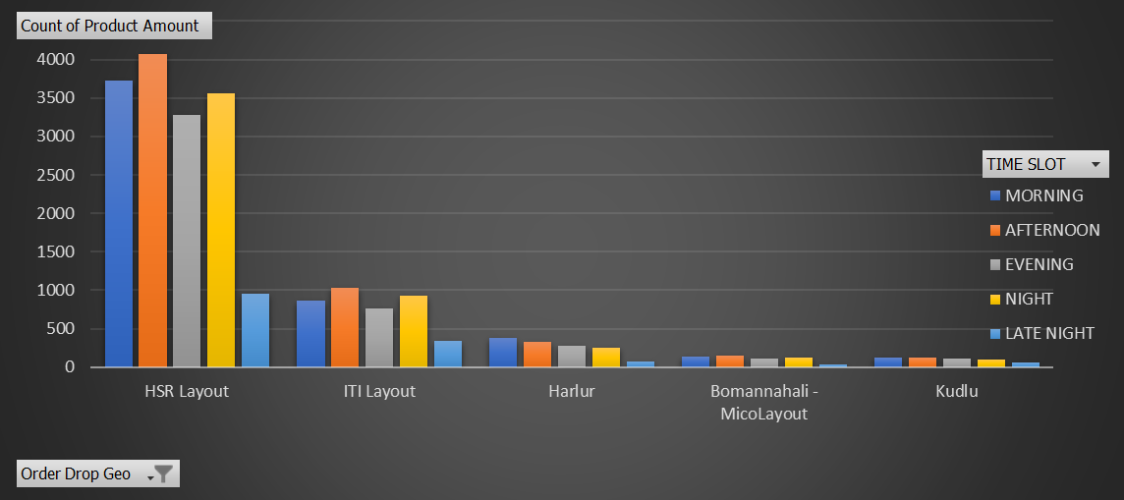

So, this data provides us the information related to order from different area and from different time zone. Here we taking only top five cities data.

This show that highest number of order which is around 4076 is come from the Harlur area and that is from the Afternoon slot period. Also the most number of order came from the Afternoon timeslot and highest number of order also come from the high value areas also.

From data we can get the idea of that most probably the people who lived near the Frencho Hypermarket area they order the highest number of product from the store.



As we can see that from the above data also highest number of total order around 15595 came from the top level area which is HSR Layout, the after ITI Layout around 3930.

But there area huge number of difference between total number of product order from HSR layout and any other area.

Out of 22721 completed order 69% around order are come from the HSR layout only which shows that how much good impact is arise for the Frencho Hypermarket

**Areas having highest increase in monthly orders (from Jan to Sep) .**

Here I’ve attached the data of total number of order form different months from the different area.



Highest counts:

April saw the largest number of product deliveries across all sites, totalling 1,776 units.

HSR Layout has the greatest product count among all sites, with 2,593 items supplied in September.

Lowest counts:

Sarjapur Road had the fewest number of product deliveries across all sites in June, with only 20 units.

Bellandur, Green Glen, and Kadubeesanhali, Prestige had the lowest product counts of all sites, with a total of 22 units supplied across many months.

Significant changes:

May's product count is much lower than April's, down 1,010 units.

Seasonal variations:

Product counts vary seasonally, with greater numbers in the first half of the year (January to April) and lower counts near the end of the year (July to September).

Product quantity counts vary among regions, reflecting seasonal differences in demand or purchasing behavior.

As we see from the both chart that there is the highest increase demand was came from the HSR Layout and that is changes and increasing on the based on seasonal changes and also increment in the month on month also.

This data also represent that how month on month the product demand is increasing.That means now people more aware about the delivery facility provided by the Frencho hypemarket and so based on that particular areas demand also increasing .

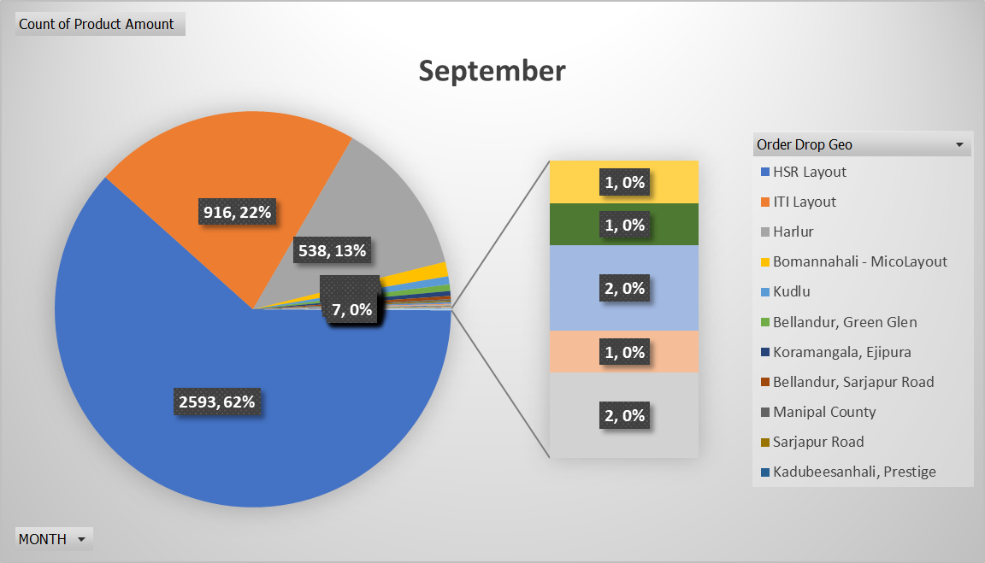

**Delivery charges as a percentage of product amount at slot and month level.**

As per our calculation this data represent that more than 10% delivery charges are given by the customer was at late night

It gives us idea that majority of people prefer to order late night for the their cravings or those people who are doing late night party’s and hangout those people may can order.

We can also see that from January to July delivery charges was at a peak.

We can also say from past data that as after the July month as the demand is also increasing company also reducing the delivery charges from the customer so that they also can order as much product as they want

But at the late night time is showing that delivery chargers is high because that time was hard to find that much of demand during that time.



As we see that during afternoon time delivery time is less that 10%.

And their sum of avg is around 5.09% only but in the other side Late Night sum of avg is highest which is 12.26% which means people prefer to order in night time more and because of that there is a high difference b/w other time slot also.

**Discount as a percentage of product amount at slot and month level.**

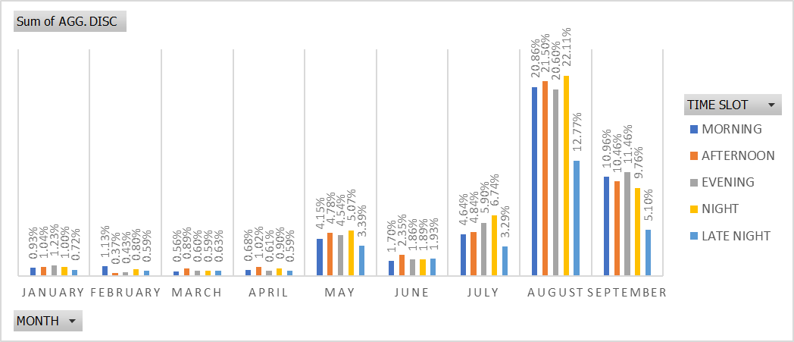

|  |  |  |  |  |  |  |
| --- | --- | --- | --- | --- | --- | --- |
| **Sum of AGG. DISC** | **Column Labels** |  |  |  |  |  |
| **Row Labels** | **MORNING** | **AFTERNOON** | **EVENING** | **NIGHT** | **LATE NIGHT** | **Grand Total** |
| January | 0.93% | 1.04% | 1.23% | 1.00% | 0.72% | 1.02% |
| February | 1.13% | 0.37% | 0.43% | 0.80% | 0.59% | 0.65% |
| March | 0.56% | 0.89% | 0.60% | 0.59% | 0.63% | 0.67% |
| April | 0.68% | 1.02% | 0.61% | 0.90% | 0.59% | 0.81% |
| May | 4.15% | 4.78% | 4.54% | 5.07% | 3.39% | 4.59% |
| June | 1.70% | 2.35% | 1.86% | 1.89% | 1.93% | 1.96% |
| July | 4.64% | 4.84% | 5.90% | 6.74% | 3.29% | 5.34% |
| August | 20.86% | 21.50% | 20.60% | 22.11% | 12.77% | 20.82% |
| September | 10.96% | 10.46% | 11.46% | 9.76% | 5.10% | 10.36% |
| **Grand Total** | **6.45%** | **6.37%** | **6.49%** | **6.82%** | **3.73%** | **6.37%** |

Above data and graph represent the demand of product at Time slot and different month level bases.

Morning Discounts: August has the biggest morning discounts, accounting for a significant portion of the total discounts, which comes to 20.86%. This suggests a deliberate attempt to draw clients in the early hours of the day with alluring deals and promotions.

August afternoon discounts are particularly noteworthy, with a high aggregate discount rate of 21.50% during the afternoon hours. This highlights a tactic to take advantage of afternoon foot activity by providing enticing discounts.

Evening Discounts: July has an impressive total discount rate of 5.90%, making it the month with the most alluring evening discounts. This demonstrates a conscious attempt to draw clients with alluring deals in the evening.

Night Discounts: August is particularly notable for providing significant nighttime discounts, with a maximum overall discount rate of 22.11%. This suggests a proactive strategy to provide attractive discounts and incentives to encourage midnight purchasing.

Late Night Discounts:

August demonstrates a significant emphasis on late-night discounts, with an aggregate discount rate reaching 12.77%. This reflects a strategic focus on attracting customers during the late-night hours with enticing promotions.

The aggressive discounting strategy reflects Freshco's commitment to meeting consumer needs, optimizing inventory turnover, and maintaining its position as a prominent shopping destination.

**Completion level analysis**

Completion rate is the rate that represent the total number of order successfully completed out oof all the order that are placed online and received by the Frencho Hypermarket.

Here completion rate level formula is as under

Completion rate level = order successfully completed/total number of order

= 22721/22823 *100

**= 99.55**

Completion rate defines how much accurate work done by the company.

Lets show total insights of this at different level also.

**Completion rate at slot vs day of the week (Sunday to Saturday) level**

|  |  |  |  |  |  |  |
| --- | --- | --- | --- | --- | --- | --- |
| **Sum of Completion status** |  |  |  |  |  |  |
|  | **MORNING** | **AFTERNOON** | **EVENING** | **NIGHT** | **LATE NIGHT** | **Grand Total** |
| Sunday | 849 | 966 | 687 | 744 | 271 | 3517 |
| Monday | 710 | 772 | 648 | 724 | 214 | 3068 |
| Tuesday | 758 | 764 | 653 | 714 | 187 | 3076 |
| Wednesday | 769 | 835 | 637 | 691 | 206 | 3138 |
| Thursday | 774 | 805 | 668 | 792 | 205 | 3244 |
| Friday | 732 | 864 | 698 | 766 | 245 | 3305 |
| Saturday | 771 | 903 | 707 | 741 | 251 | 3373 |
| **Grand Total** | **5363** | **5909** | **4698** | **5172** | **1579** | **22721** |

Above data shows that out of all 22721 order highest number of order was order in the Sunday and Saturday afternoon respectively 966 and 903 and along with that highest number of order out of all timeslot is also at afternoon.

This suggests that afternoon hours are the most productive for finishing orders, presumably because of the best workforce and most efficient operations during these times.

Which represent that in free time of Sunday people like to shopping of any kind of grocery stuff or any home related product may prefer by the people.

As we can see that from the graph that highest number of completion rate done at Sunday or Saturday as compare to the any other day.

Also it represent that highest number of order complete done at Sunday and Saturday respectively 3517 and 3373. This may be explained by higher customer demand at the end of the week, which forced Freshco to devote more resources to order fulfillment on those days.

Overall, while Freshco maintains consistent completion rates throughout the week, there are slight variations across days and time slots. Addressing challenges during nighttime operations could further improve overall efficiency and customer service levels.

**Completion rate at drop area level.**

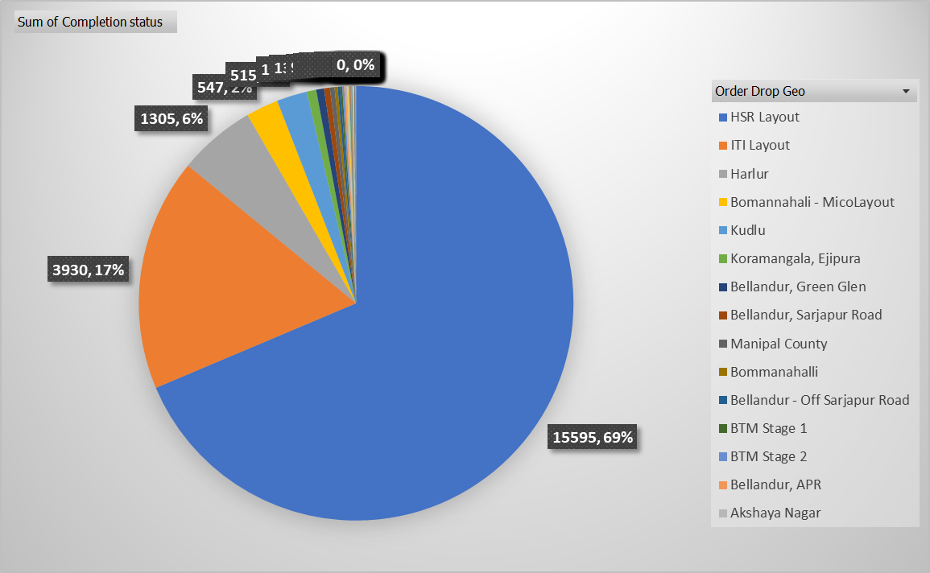

HSR Layout records the highest completion status with 15,595 completed orders, indicating efficient order fulfillment and customer satisfaction in this area.

ITI Layout and Harlur follow HSR Layout with substantial completion rates of 3,930 and 1,305 orders, respectively. This suggests effective order processing and fulfillment in these locations as well.

While most locations demonstrate satisfactory completion rates, areas with lower completion rates indicate opportunities for improvement in order processing and fulfillment processes to enhance customer satisfaction and loyalty.

These insights provide valuable information on the completion status across different locations, enabling Freshco Hypermarket to identify areas of strength and opportunities for improvement in order fulfillment processes and customer service delivery.

**Completion rate at number of products ordered level.**

Orders containing 1 to 5 products demonstrate the highest completion statuses, with over 4,000 orders falling within this range. This suggests that Freshco's fulfillment processes are particularly efficient for smaller orders, which are likely easier to handle and process.Gradual Decline in Completion with Increasing Product Count.

orders containing 11 or more products exhibit a significant drop in completion statuses, with only a few hundred orders falling within this category. This decline underscores the challenges associated with handling larger and more complex orders, which may require additional time and resources for processing and fulfillment.

As the product was increasing the

The data suggests a correlation between order size and fulfillment efficiency, with smaller orders being processed more promptly and with higher completion rates compared to larger orders. This highlights the importance of optimizing processes and resources to effectively manage orders of varying sizes and complexities.

**Completion rate at from my analysis from number of Product at time slot and Days of week**

Afternoon has the highest number of completed orders (5,909), followed by Morning (5,363), Night (5,172), Evening (4,698), and Late Night (1,579). This indicates that most orders are completed during the daytime hours.

weekdays see significantly higher completion rates compared to weekends, with 15,831 orders completed on weekdays and 6,890 orders completed on weekends. This suggests that Freshco's order fulfillment operations are more active and efficient during weekdays, likely due to higher customer demand and operational capacity.

Freshco may need to allocate resources more effectively during weekends, especially during Late Night hours, to ensure consistent order fulfillment and customer satisfaction throughout the week. Analyzing the factors contributing to lower completion rates on weekends, such as staffing levels, order volume fluctuations, and operational workflows, can help identify areas for improvement and optimization.

**Completion rate at source level.**

Organic channels demonstrate the highest completion status with 6,655 completed orders, Google emerges as the most effective digital marketing channel, with 5,324 completed orders, showcasing its significance in driving online sales and conversions.

Facebook and Instagram also contribute significantly to order completions, with 2,607 and 2,769 completed orders, respectively. These platforms likely play crucial roles in engaging with customers and driving traffic to Freshco's online platform.

Freshco's diverse marketing mix, including digital channels like Google and social media platforms like Facebook, Instagram, and Snapchat, along with traditional offline campaigns, contributes to a balanced approach in reaching and engaging with customers across various channels.

Analyzing the performance of each marketing channel can help Freshco optimize its marketing strategies further. By identifying the most effective channels and reallocating resources accordingly, Freshco can maximize its marketing ROI and enhance overall customer acquisition and retention efforts.

**Customer level analysis**

**Aggregated LTV at customer acquisition source level.**

Snapchat demonstrates the highest average Lifetime Value (LTV) among all marketing channels, with an average LTV of 389.48. Google and Facebook also show relatively high average LTV values, with averages of 383.07 and 373.08, respectively. These digital marketing platforms are effective in attracting valuable customers with significant long-term revenue potential.

Instagram, Offline Campaigns, and Organic channels exhibit slightly lower average LTV values, ranging from 349.11 to 373.05

Channels with slightly lower average LTV values, such as Instagram, Offline Campaigns, and Organic channels, may benefit from optimization strategies aimed at increasing customer lifetime value.

Freshco can leverage these insights to optimize its marketing strategies by allocating more resources to channels with higher average LTV values and implementing targeted campaigns to enhance customer lifetime value across all channels.

**Average Revenue at differerent customer acquisition source level**

With an average of 363.52, Snapchat has the highest average Revenue per order of all the customer acquisition methods. This suggests that, when compared to consumers from other sources, those gained through Snapchat often yield the most income per order.

With an average revenue per order of 363.05, Google comes in second, showing good performance in terms of revenue creation per order.

The average revenue per order figures for Facebook, offline campaigns, and organic channels are likewise very high, ranging from 349.06 to 346.72. With an average revenue per order of 322.85, Instagram is the customer acquisition source with the lowest average revenue.

Freshco can leverage these insights to optimize its marketing strategies by allocating more resources to channels with higher average Revenue per order values and implementing targeted campaigns to enhance revenue generation per transaction across all channels.

**average Revenue(Product amount after discount) at acquisition month level**

With an average of 401.83, May exhibits the highest average Revenue per order of all the months. This indicates that, in comparison to other months, May is when clients tend to spend more per transaction.With an average revenue per order of 376.09 in April, it follows closely, demonstrating good performance in terms of revenue creation per order.

The comparatively high average Revenue per order numbers for the months of January and February range from 367.17 to 367.27. With an average of 286.69, September has the lowest average Revenue per order of all the months.

Through targeted promotions or product offerings catered to client preferences during certain periods, Freshco may use these data to modify its marketing and promotional activities and profit from peak months with higher average transaction values. In order to find chances for improvement, such as changing pricing tactics, marketing seasonal items, or increasing customer involvement during slower months to drive expenditure, Freshco may further investigate the variables leading to the variations in average Revenue per order by month.

With an average Lifetime Value of 420.14, May exhibits the highest LTV of all the months. This indicates that, in comparison to other months, clients acquired in May typically create the maximum revenue throughout the course of their lifetime.

August performs well in terms of long-term revenue potential, coming in close second with an average LTV of 405.26.

The comparatively high average LTV values for the months of July and April range from 379.65 to 378.91. With an average of 319.06, September has the lowest average LTV of the months.

According to the statistics, there may be seasonal tendencies in the average lifetime value, with larger values seen in certain months. Through focused retention efforts, loyalty programs, or customized marketing campaigns aimed at maximizing customer lifetime value, Freshco may use these data to modify its marketing and operational strategies and profit from peak months with higher average Lifetime Values.



This data shows the time slot along with order rating at total count of product and sum of discount and also delivery charges.

From the data we highlight the insights that those customer who order highest number of product from the store gives the highest delivery charges. The total discount offered across all orders is $510,163.The total delivery charges collected amount to $468,946.Morning has the highest total discount of $81,181, followed closely by Afternoon with $93,820.

Even though they are less in quantity, late night purchases have the greatest total delivery costs—$32,680—and the largest overall discount—$10,255. This implies that in order to properly fulfill Late Night requests, further incentives and resources could be needed.By examining the connection between the quantity of products, the time slots available, and the related expenses, Freshco can maximize its discount and delivery charge methods. Effective revenue and cost balance may be achieved by modifying pricing models or implementing tiered pricing according to the number of products.

**Delivery analysis**

**Average overall delivery time at month and weekday/weekend level**.

According to the statistics, there may be seasonal tendencies in the average lifetime value, with larger values seen in certain months (like May and August) than in others (like September).

Through focused retention efforts, loyalty programs, or customized marketing campaigns aimed at maximizing customer lifetime value, Freshco may use these data to modify its marketing and operational strategies and profit from peak months with higher average Lifetime Values.

According to the statistics, there may be seasonal tendencies in the average total delivery time, with larger delivery times seen in certain months (like May and April) than in others (like September).

By employing route optimization techniques to reduce delivery times during peak hours, modifying personnel levels based on projected delivery times, or better allocating resources, an understanding of these trends can help Freshco manage its delivery operations.

In order to find opportunities for optimization, Freshco can further analyze the factors that contribute to longer delivery times on weekends and during specific months. Some of these optimization strategies include streamlining logistics procedures, improving customer communication about delivery expectations, or utilizing technology to increase efficiency and streamline delivery operations.

**Average overall delivery time at slot level.**

With an average delivery time of around 17 minutes and 23 seconds, late-night deliveries have the shortest overall average delivery time of any time slot. This implies that, in comparison to other timeslots, deliveries sent late at night are typically more effective and swift.

The typical total delivery times for morning and afternoon deliveries are similarly very quick, averaging between around 25 minutes and 25 minutes and 43 seconds.

When compared to other time slots, evening and night deliveries have lengthier average total delivery times; these timings typically range from around 22 minutes and 29 seconds to 25 minutes and 30 seconds.

in order to guarantee prompt and satisfying delivery experiences for consumers, Freshco may think about allocating resources during time slots with lengthier typical delivery times, including Evening and Night. In order to find opportunities for optimization, such as enhancing route planning, streamlining delivery schedules, or utilizing technology solutions to improve delivery efficiency and shorten overall delivery times, Freshco can further analyze the factors contributing to variability in average overall delivery times by time slot.

**Delivery time and delivery area.**

Above chart shows us that highest taking avg time area was Mahadevpura which takes around 2:25:00 and then after pattandur is around 1:27:00 which means either it was a high traffia area or may be its to far from the market.

Those area who takes nearly 30 seconds times are mostly the near by area from the market.

**Delivery charges with slot or delivery area.**

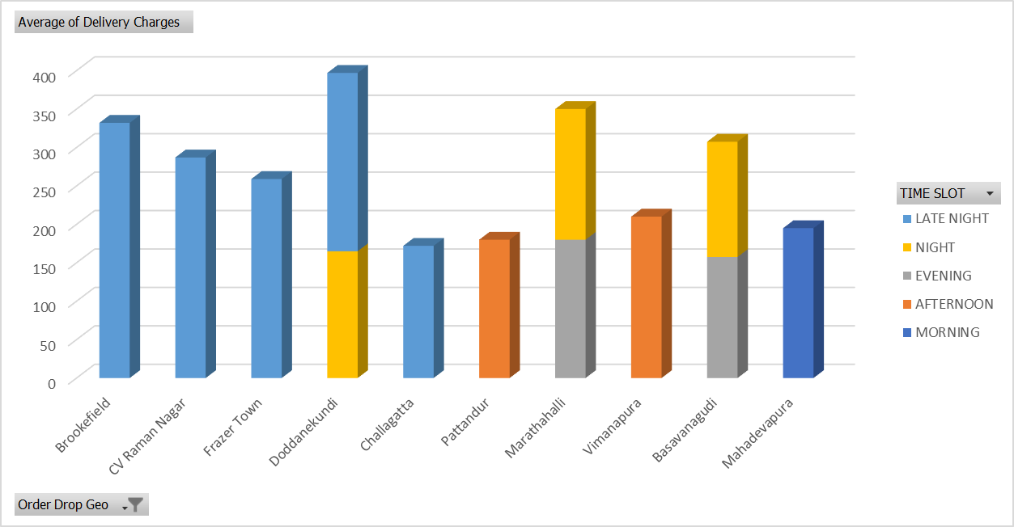

This data represent the top 10 cities delivery charges and according to top area.

The average delivery fees for Brookefield, CV Raman Nagar, and Frazer Town are $332, $287, and $259, respectively, and are constant throughout all time periods.

With an average delivery fee of $210 for all time slots, Vimanapura has the highest average delivery fees among the places on the list. This suggests that the cost of delivery to Vimanapura is often greater than for other places.

With an average delivery fee of $256.40, late-night deliveries have the highest average delivery costs of any time period. This implies that there can be extra fees associated with deliveries made during late hours because of things like higher operating expenses or a shortage of delivery windows.

In order to maintain competitive pricing and efficiently cover operating costs, Freshco may take into account modifying delivery prices depending on variables including location, time of day, and delivery demand.

In order to find opportunities for optimization, such as streamlining delivery routes, negotiating rates with outside delivery partners, or implementing dynamic pricing models based on supply and demand dynamics, Freshco can further analyze the factors contributing to variability in average delivery charges by location and time slot.

**Conclusion**

In conclusion, Freshco Hypermarket is able to optimize its operations, improve customer happiness, and propel sustainable growth in a competitive market landscape by utilizing insights from delivery analysis, completion analysis, customer analysis, and order level analysis. Through the prioritization of data-driven decision-making and continuous improvement activities, Freshco may establish itself as a prominent supplier of dependable and convenient retail services, hence cultivating long-term success and customer loyalty.